Rhinoplasty in Vietnam: Structural & Rib Cartilage Nose Surgery
Meta Description: Explore structural and rib cartilage rhinoplasty in Vietnam with Dr. Maris, including hospital-based surgery, recovery, risks and starting prices.
Changing the nose requires more than selecting a bridge height or copying a reference photograph. Dr. Maris personally assesses your nasal structure, skin, proportions, previous surgery and goals before recommending structural rhinoplasty or autologous rib cartilage reconstruction when appropriate. Surgery is performed at City International Hospital (CIH) in Ho Chi Minh City, Vietnam.

Understanding Rhinoplasty

Understanding Rhinoplasty before deciding
Rhinoplasty is surgery performed to change the shape, proportions or structural characteristics of the nose.
The American Society of Plastic Surgeons describes rhinoplasty as surgery that may address concerns involving nasal size, bridge width, profile, tip shape, nostril dimensions and asymmetry. It may also be used in selected cases to address structural problems affecting breathing. (American Society of Plastic Surgeons)
For cosmetic rhinoplasty, planning should consider the relationship between the nose and the rest of the face rather than evaluating the nose as an isolated feature.
Important anatomical considerations may include:
- nasal bridge height and width
- tip projection and definition
- nasal length
- nostril shape
- columellar support
- septal structure
- skin thickness
- cartilage strength
- facial asymmetry
- previous nasal surgery
No single nose shape is appropriate for every patient.
The objective of consultation is to identify which anatomical changes are realistic and whether surgery is appropriate—not to guarantee a predetermined shape.

Structural Rhinoplasty
“Structural rhinoplasty” is commonly used to describe an approach in which the internal support of the nose is evaluated and, where required, reconstructed or reinforced rather than changing only the visible bridge.
Depending on anatomy, structural work may involve cartilage grafting, modification of existing cartilage or another form of support.
However, structural rhinoplasty is not one universally standardized operation.
Different surgeons may use the term for different combinations of:
- bridge augmentation
- tip support
- septal reconstruction
- columellar support
- cartilage grafts
- implant-based augmentation
- correction of previous surgical changes
For this reason, DR. MARIS should explain what will actually be performed rather than relying on the phrase “structural rhinoplasty” alone.

Structural Rhinoplasty with Synthetic Material
The approved DR. MARIS international price list names one procedure:
Structural Rhinoplasty (Synthetic Cartilage)
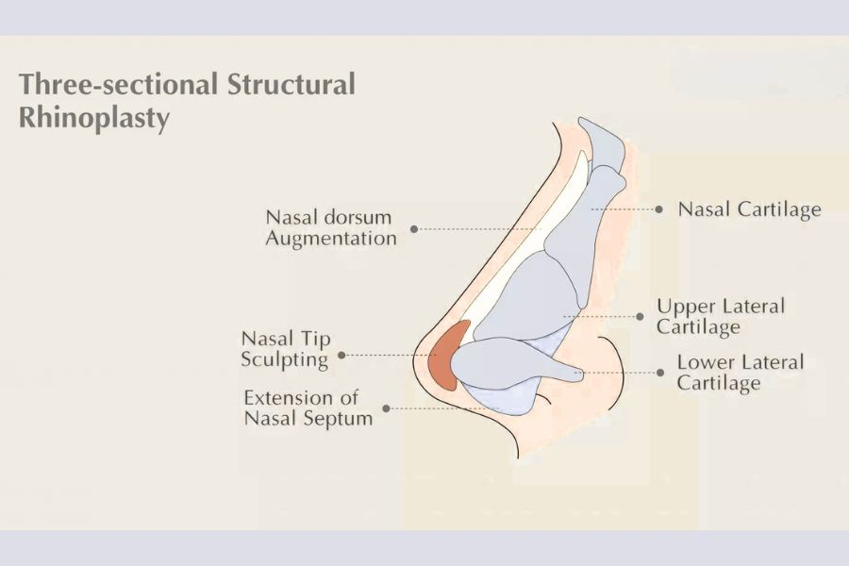
Three sectional structural Rhinoplasty
The exact material referred to by the term “Synthetic Cartilage” has not been identified in the supplied document.
It should therefore not automatically be described as silicone, ePTFE, Gore-Tex, Medpor or another specific implant material without verification.
During consultation, Dr. Maris should assess whether an implant-based structural approach is appropriate based on:
- existing nasal anatomy
- skin thickness
- desired degree of augmentation
- tip support
- previous procedures
- tissue quality
- individual surgical risks

Autologous Rib Cartilage Rhinoplasty
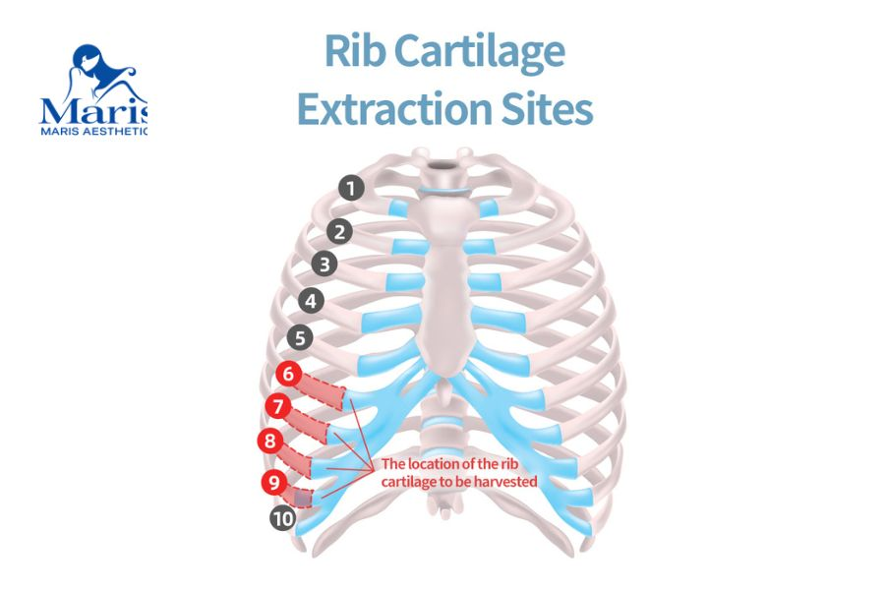
A diagram of autologous Rib Cartilage Rhinoplasty
Autologous rib cartilage rhinoplasty uses cartilage harvested from the patient's own rib as graft material for nasal reconstruction.
“Autologous” means the tissue comes from the same patient.
Rib cartilage can provide a relatively substantial amount of graft material and can be particularly useful when significant structural support is required or when sufficient septal cartilage is unavailable.
A published review notes that rib cartilage plays an important role in structural rhinoplasty, particularly in revision and post-traumatic cases where septal cartilage may be insufficient and stronger structural grafting is required. (PubMed)
This can make rib cartilage relevant for selected patients requiring more extensive reconstruction.
However, rib cartilage rhinoplasty involves two surgical sites:
- the nose, and
- the chest donor site where the cartilage is obtained.
It is therefore a more complex decision than choosing an implant solely because it avoids cartilage harvesting.

When Might Rib Cartilage Be Considered?

Structural rhinoplasty assessment before nose surgery in Vietnam
Rib cartilage may be discussed when nasal reconstruction requires more graft material or structural support than is readily available from the nose.
Potential scenarios may include:
- major structural augmentation
- significant loss of existing nasal support
- previous rhinoplasty that has depleted available septal cartilage
- selected revision cases
- reconstruction following previous implant problems
- short or contracted nasal anatomy where additional structural grafting may be needed
- complex nasal asymmetry
These examples describe situations in which costal cartilage may be considered medically; they do not mean that every patient with these concerns requires rib cartilage.
Dr. Maris must assess the individual nose before recommending a graft source.

Synthetic Material vs Autologous Rib Cartilage
Patients often ask which option is “better.”
The more useful question is which material is appropriate for the anatomy and surgical objective.
Consideration | Synthetic Material | Autologous Rib Cartilage
Material source | Manufactured material | Patient's own rib cartilage
Chest donor site | No | Yes
Additional chest incision | No | Yes
Available structural material | Depends on implant | Substantial cartilage may be harvested
Biological tissue | No | Yes
Implant-specific complications | Applicable | No synthetic nasal implant
Graft warping/resorption | Not applicable in the same way | Possible
Donor-site complications | No rib harvest | Possible
Appropriate for revision | Case-dependent | Often useful when substantial graft material is required
Neither option should be promoted as universally superior.
A recent systematic review comparing autologous and alloplastic augmentation-rhinoplasty grafts found different complication profiles between the two categories, reinforcing that graft selection requires individualized assessment rather than a simple “natural versus artificial” marketing claim. (PubMed Central (PMC))

Rib Cartilage Has Its Own Considerations
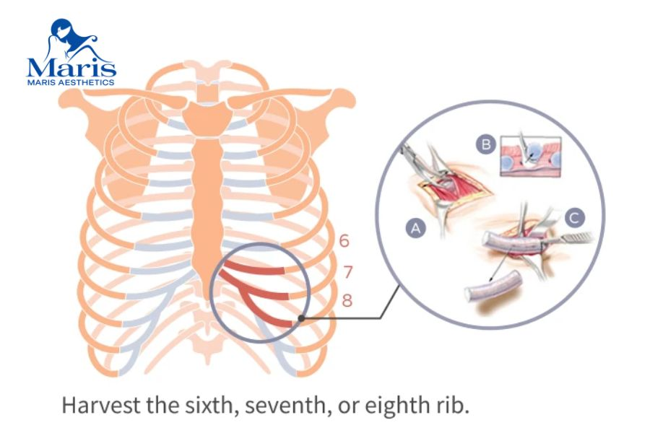
Rib Cartilage Has Its Own Considerations
Using the patient's own cartilage does not mean the procedure is risk-free.
Potential graft-related issues can include:
- cartilage warping
- graft resorption
- infection
- displacement
- contour irregularity
- need for revision
Harvesting rib cartilage also creates potential donor-site concerns.
Recent literature identifies possible donor-site problems such as:
- pain
- chest scarring
- hypertrophic scar formation
- chest-wall changes
- pneumothorax, although uncommon
(PubMed Central (PMC))
These considerations should be discussed during informed consent rather than presenting autologous cartilage as automatically complication-free.

Who May Consider Rhinoplasty?
Rhinoplasty may be considered by adults who want to change selected nasal features and are medically suitable for elective surgery.
Common reasons for consultation can include:
- a low or under-projected nasal bridge
- concerns about nasal tip shape
- a nose that appears disproportionate to the face
- nasal asymmetry
- previous rhinoplasty with an unwanted result
- loss of structural support following earlier surgery
- an existing nasal implant that requires reassessment
- trauma-related changes
ASPS also emphasizes realistic expectations and appropriate general health when evaluating candidates for rhinoplasty. (American Society of Plastic Surgeons)
The presence of a cosmetic concern alone does not establish which procedure or graft material is suitable.

Common Concerns We Address

Bridge Height and Facial Proportion

Facial Proportion
Patients may seek rhinoplasty because they feel the nasal bridge is relatively low or does not balance with other facial features.
Increasing bridge height should still be planned according to the patient's existing anatomy.
A specific bridge height or profile should not be guaranteed.

Nasal Tip Shape and Projection
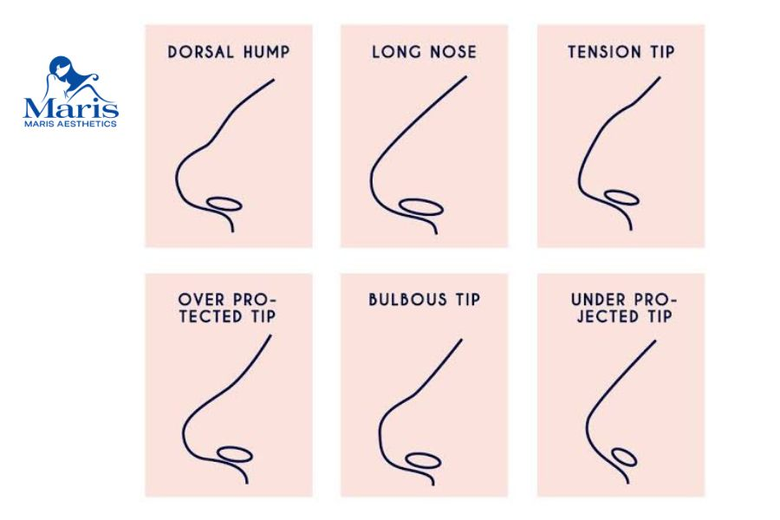
Nasal Tip Shape and Projection
Tip definition depends on cartilage anatomy, skin thickness and underlying support.
Simply increasing the bridge does not necessarily address tip concerns.

Nasal Asymmetry
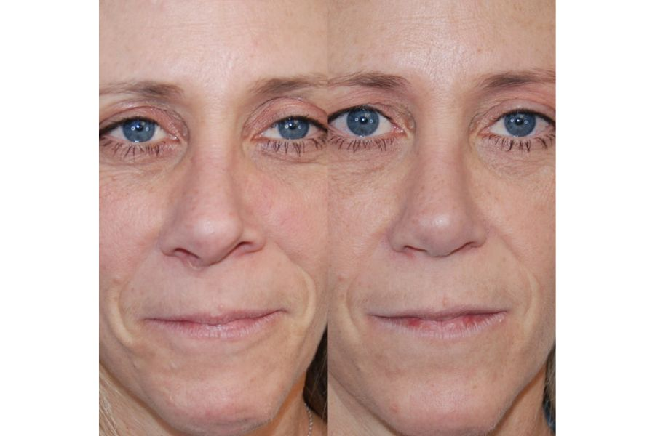
Before and after of a patient who has nasal asymmetry
No human face is perfectly symmetrical.
ASPS specifically notes that some degree of facial asymmetry is normal and that rhinoplasty cannot guarantee complete symmetry. (American Society of Plastic Surgeons)

Previous Rhinoplasty
A nose that has already undergone surgery may contain:
- altered cartilage
- scar tissue
- an existing implant
- reduced septal cartilage
- weakened support
- skin or soft-tissue changes
Revision planning can therefore be substantially different from a first operation.

Dr. Maris's Approach to Rhinoplasty
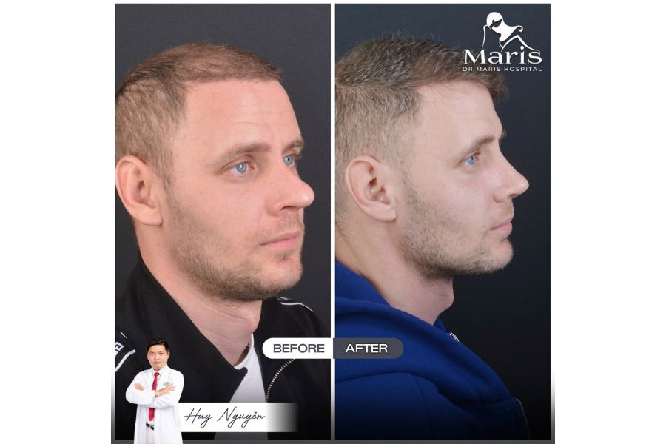
A result of customer who got rhinoplasty in Vietnam
Dr. Maris / Dr. Tran Minh Huy has 6+ years of cosmetic surgery experience according to the approved brand information supplied for this page.
Dr. Maris personally:
- conducts the consultation
- examines the nose and facial proportions
- reviews previous surgery where relevant
- determines whether structural reconstruction is needed
- develops the surgical plan
- performs the operation
- participates in postoperative follow-up
The consultation should establish both what the patient wants to change and what the anatomy can realistically support.
For international patients, preliminary assessment may begin online before travelling to Vietnam.

How Rhinoplasty Surgery Is Planned

Planning Rhinoplasty Surgery before going to Vietnam
Rhinoplasty technique varies considerably between patients.
ASPS describes rhinoplasty as involving either a closed approach, with incisions concealed inside the nose, or an open approach, which includes an incision across the columella in addition to internal incisions. (American Society of Plastic Surgeons)
This is general medical information.
It does not establish which approach Dr. Maris routinely uses.

Structural Assessment
Before surgery, factors may include:
- nasal bones
- septum
- existing cartilage
- bridge
- tip support
- skin thickness
- nostril proportions
- previous implants or grafts

Graft or Implant Selection
Where augmentation or reconstruction is required, the material should be selected according to the surgical problem rather than price alone.

Facial Proportion
A surgical plan should consider how changes to the bridge, tip and length relate to the forehead, eyes, lips and chin.

Previous Surgery
Revision cases may require additional planning because normal anatomical planes may be altered by scar tissue and earlier operations.

Revision or Complex Rhinoplasty
Patients seeking revision surgery may already feel uncertain about undergoing another operation.
Revision rhinoplasty can be more complex because the surgeon is working with anatomy that has already been altered.
Issues may include:
- scar tissue
- implant displacement
- visible or palpable implant edges
- asymmetry
- inadequate support
- unwanted bridge height
- tip distortion
- cartilage depletion
- tissue contraction
- previous infection
Autologous rib cartilage can be particularly relevant when previous operations have left insufficient septal cartilage for reconstruction. (PubMed)
However, rib cartilage is not automatically required for every revision.

What Should Revision Patients Send Before Travelling?
Where available, international patients should prepare:
- dates of previous rhinoplasty procedures
- previous operative reports
- implant information
- previous cartilage-graft information
- photographs before and after previous operations
- history of infection or wound problems
- current symptoms
- recent imaging if clinically requested
Dr. Maris can review this information during preliminary planning.
A website or online photograph alone cannot determine whether a failed or unwanted result can be fully corrected.

Surgery at City International Hospital
Rhinoplasty with DR. MARIS AESTHETICS is performed in a hospital environment at City International Hospital (CIH), Ho Chi Minh City.
DR. MARIS AESTHETICS does not represent itself as the owner of City International Hospital.
The hospital setting provides access to hospital infrastructure, including emergency and resuscitation support when required.
International patients comparing providers should consider:
- who will perform the operation
- surgeon involvement before and after surgery
- surgical environment
- anesthesia arrangements
- preoperative assessment
- postoperative monitoring
- management of potential complications
alongside procedure price.

Recovery & Aftercare
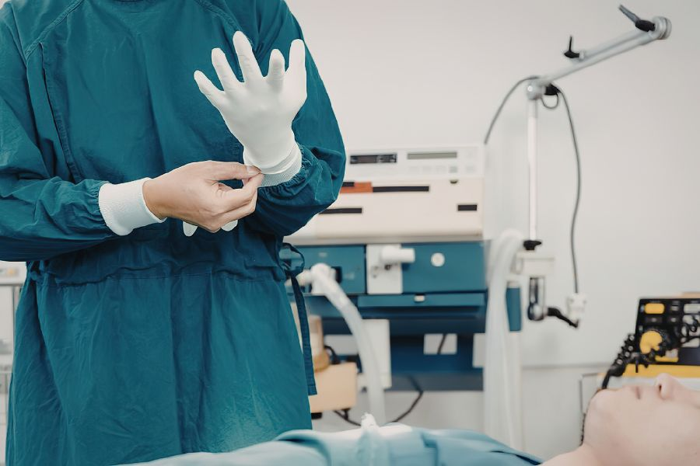
Hospital based rhinoplasty surgery at City International Hospital
Rhinoplasty recovery occurs in stages.
During early recovery, a nasal splint, internal support or dressings may be used depending on the operation. Swelling and bruising can occur.
ASPS notes that while initial swelling typically improves over the first several weeks, the nasal contour can continue refining for many months and may take approximately a year to fully settle. (American Society of Plastic Surgeons)
Patients undergoing rib cartilage rhinoplasty must also account for healing at the chest donor site.
Recovery can therefore depend on:
- extent of nasal reconstruction
- primary versus revision surgery
- whether rib cartilage is harvested
- swelling
- wound healing
- individual biological response
Recovery timing depends on the procedure and individual condition and will be discussed during consultation.
International patients should not schedule their return flight based solely on a generic recovery timeline found online.

Risks & Considerations
Rhinoplasty carries potential risks.
ASPS identifies recognized complications including:
- anesthesia risks
- infection
- bleeding
- changes in skin sensation
- breathing difficulty
- poor wound healing
- scarring
- persistent swelling
- skin discoloration
- nasal septal perforation
- unsatisfactory nasal appearance
- possible revision surgery
(American Society of Plastic Surgeons)
Additional risks depend on the specific material and technique.

Synthetic Material Considerations
Potential implant-specific complications depend on the exact material used and should not be generalized until the DR. MARIS implant has been confirmed.

Rib Cartilage Considerations
Additional issues can include:
- graft warping
- resorption
- graft displacement
- infection
- chest scar
- donor-site pain
- other rib-harvest complications
(PubMed Central (PMC))
Individual risk should be discussed directly with Dr. Maris before surgery.

Results & Realistic Expectations
Rhinoplasty may change the shape, proportions or structural characteristics of the nose.
It cannot guarantee:
- perfect facial symmetry
- an identical result to a reference photograph
- an invisible scar
- permanent absence of swelling
- zero possibility of revision
- a specific bridge height
- a universally defined “natural” result
Swelling can also make early results misleading.
ASPS notes that nasal refinement continues gradually and final contour can take up to a year to become apparent. (American Society of Plastic Surgeons)
Revision or complex reconstruction may require particularly patient expectations because scar tissue and previous structural changes can limit what can reasonably be achieved.

Rhinoplasty Cost in Vietnam
The approved DR. MARIS AESTHETICS International Price List currently includes two rhinoplasty procedures:
Procedure | Starting Price (VND) | AUD Reference | USD Reference | NZD Reference
Structural Rhinoplasty (Synthetic Cartilage) | 114,750,000 VND | A$6,380 | US$4,410 | NZ$7,170
Rib Cartilage Rhinoplasty (Autologous) | 249,750,000 VND | A$13,880 | US$9,610 | NZ$15,610

Why Does Rib Cartilage Rhinoplasty Cost More?
The price document does not provide an explanation for the difference.
It would therefore be inappropriate to state that the higher price includes a specific operation duration, hospital stay, anesthesia package or graft-harvesting fee unless those inclusions have been verified.
Rib cartilage rhinoplasty generally involves an additional donor site and more extensive graft preparation, but the exact DR. MARIS pricing structure should be confirmed separately.

International Patients Travelling to Vietnam

Rhinoplasty consultation with Doctor in Ho Chi Minh City Vietnam
Patients from Australia, New Zealand, the United States, Europe and other markets may begin with an online consultation.
For primary rhinoplasty, you may be asked to provide:
- front-view photograph
- side-profile photographs
- oblique views
- primary concerns
- previous nasal trauma
- medical history
- medications
- allergies
Revision patients should also provide previous surgical information whenever available.
A remote assessment can help determine whether further evaluation is appropriate, but it cannot replace the physical examination and preoperative medical assessment required before surgery.

Why International Patients Consider Dr. Maris
The DR. MARIS surgical model emphasizes direct surgeon involvement and individualized planning.
Patients can expect:
- consultation personally conducted by Dr. Maris
- direct nasal and facial assessment
- review of previous procedures where relevant
- individualized implant or graft planning
- surgery personally performed by Dr. Maris
- postoperative follow-up involving Dr. Maris
- hospital-based surgery at City International Hospital
- online preliminary consultation for international patients
- published starting prices
- particular consideration of complex and revision cosmetic surgery
The aim is to identify an appropriate surgical plan rather than select a procedure solely from a price list.

Frequently Asked Questions

How much does rhinoplasty cost in Vietnam with Dr. Maris?
DR. MARIS currently lists Structural Rhinoplasty (Synthetic Cartilage) from 114,750,000 VND, with reference prices of A$6,380, US$4,410 and NZ$7,170. Autologous rib cartilage rhinoplasty starts from 249,750,000 VND, with reference prices of A$13,880, US$9,610 and NZ$15,610. Prices are indicative starting rates and final cost is confirmed after assessment.

What is structural rhinoplasty?
Structural rhinoplasty generally refers to surgery that evaluates and modifies the supporting framework of the nose rather than changing only surface appearance. It may involve work on the bridge, tip, septum or supporting grafts. However, the term is not one standardized technique. Dr. Maris needs to assess your actual nasal structure before explaining what structural changes are appropriate.

What is autologous rib cartilage rhinoplasty?
Autologous rib cartilage rhinoplasty uses cartilage harvested from your own rib to provide graft material for nasal reconstruction. Rib cartilage can provide substantial structural material and is particularly useful in selected complex or revision cases when septal cartilage is insufficient. (PubMed) Because cartilage must be harvested from the chest, patients must also consider donor-site healing and scarring.

Is rib cartilage rhinoplasty better than a synthetic implant?
Not universally. Each option has different advantages and risks. Rib cartilage provides biological graft material and can be valuable when extensive reconstruction is required, but it involves a chest donor site and carries risks such as warping or resorption. Synthetic materials avoid rib harvesting but introduce implant-specific considerations. The appropriate option depends on anatomy, previous surgery and the required structural correction.

Does rib cartilage rhinoplasty leave a chest scar?
Yes, obtaining autologous rib cartilage requires a surgical incision at the donor site, so describing the procedure as scarless would be inaccurate. Scar appearance varies between patients. Published research also identifies hypertrophic chest scarring among the potential donor-site complications of costal cartilage harvest. (PubMed) The expected incision and scar should be discussed with Dr. Maris before surgery.

Can a previous rhinoplasty be corrected?
Some previous rhinoplasty problems may be suitable for revision surgery, but correction cannot be guaranteed. Dr. Maris needs to assess existing cartilage, implants, scar tissue, skin, structural support and previous surgical changes. In complex cases where septal cartilage is limited, rib cartilage may provide additional graft material for reconstruction. (PubMed)

How long does swelling last after rhinoplasty?
Visible swelling usually improves progressively, but the nose can continue changing for considerably longer than the initial recovery period. ASPS notes that although early swelling decreases over several weeks, final nasal refinement may take up to approximately one year. (American Society of Plastic Surgeons) Your own recovery can differ depending on the surgical technique, skin characteristics and whether the procedure is primary or revision rhinoplasty.

How long should I stay in Vietnam after rhinoplasty?
There is no single appropriate duration for every patient. The recommended stay depends on the operation, early healing, postoperative reviews and whether rib cartilage has been harvested. Revision surgery may also require a different schedule from uncomplicated primary rhinoplasty. Dr. Maris should confirm your recommended stay before you finalize international travel.

Can Dr. Maris review my nose before I travel to Vietnam?
Yes. International patients may begin with an online consultation and submit appropriate photographs and medical information for preliminary assessment. If you have undergone previous rhinoplasty, provide implant information, previous operative reports and relevant photographs where available. Online assessment supports planning but does not replace the physical examination and medical evaluation required before surgery.

Will my rhinoplasty look exactly like my reference photograph?
No exact result should be guaranteed from a reference image. A photograph can help communicate preferences, but your final surgical plan must account for your own bones, cartilage, skin thickness, existing proportions and previous procedures. Natural facial asymmetry also means that perfect symmetry cannot be promised. (American Society of Plastic Surgeons)

